Name: Khanh Vy Tran
ID: 120175245
Refer to the In Class Discussion Questions posted in Week2
Each student complete the class diagram to support:
- one of the Composition questions, not done in class
- one of the Generalization question, not done in class
Copy your diagrams to an MSWord compatible file and include your .vpp in your submission.
Questions are assigned by the first letter of your First Name:
A-H: Question 1, 5
I-O: Question 2, 6
P-Z: Question 3, 7
Question 2: Flower Shop (Composition)
A flower shop sells flower arrangements. Each flower has a price associated to it.
An arrangement uses combinations of flowers.
Please create a class diagram to reflect this information.
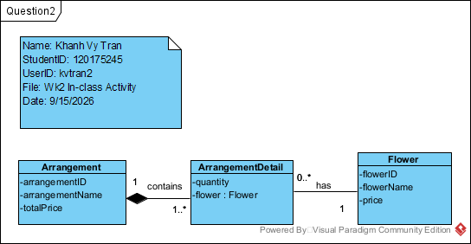

Question 6: Admission passes (Generalization)
We’re creating Admission Passes for our music festival.
Our adult admission has the individuals name, address, picture, and if they’ve paid for parking, the parking lots that they are able to park in.
Youth admission passes are similar to adult admission passes, the colour of the pass changes, so to flag that the person wearing the pass isn’t able to purchase alcohol.
A child’s pass doesn’t have parking associated with it.
A worker’s pass is similar to the above. Workers have a designated parking lot and a job title.
Please create a class diagram to reflect this information.
